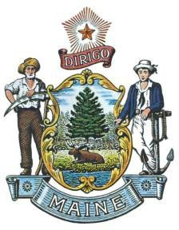
Maine State Archives
Department of the Secretary of State
Shenna Bellows
Secretary of State

STATE OF MAINE POLICY ON

PRESERVATION OF STATE GOVERNMENT RECORDS

TO: All State Employees March 2025
This policy applies to all employees of Maine State government, including all Executive Branch agencies, Legislative Branch, the Constitutional Offices, and semi-independent agencies.

Actions by ALL STATE EMPLOYEES:

Every State employee shall comply with this policy by taking the following three actions:
- Properly manage/preserve records (regardless of format) for the time required by approved General and Agency retention schedules. Managers/supervisors must secure and manage the records of departing employees (particularly those records on computers) and notify Archives when executive level employees leave for potential archival record capture. (Further information is included in the training or by contacting Records Management staff at the Maine State Archives.)

Review the following Minimum Standards Training:

For Records Officers and RO Assistants only – RM Training for Records Officers and Assistants (pdf) | Records Officers or Assistants review the minimum standards training to complete the policy requirements.
For all other State Employees – Records Management Basic Principles (ppsx) or alternative pdf format | Other State employees (other than those taking the Records Officer training above), review this as part of the minimum standards training for Records Management.
- All state employees must annually sign the acknowledgement form within 60 days of receiving notice. NOTE: The acknowledgement form active link will be removed after six months of original posting date

Policy Effective Date: October 30, 2013

In accordance with Title 5, Chapter 6 and Maine State Archives Rule Chapter 1: State and Local Government Agency Records Programs, Directors and Agency Heads are responsible for establishing and maintaining an efficient and continuous records management program. Agency Directors are also responsible for appointing Agency Records Officers.

Agency Directors and Records Officers shall ensure all State employees (in their agency): understand they are creating public records and know the records for which they are responsible; are aware of the General Schedules and any Agency Specific Schedules; and have contact information for their agency's Records Officer.
Records Officers shall have knowledge of their agency and its records; the functions to create an inventory of records and retention schedules; and maintain an office file plan and keep these updated.

Any questions regarding this policy should be directed to the Maine State Archives Records Management Division, recordsmanagement.archives@maine.gov.

Sincerely,
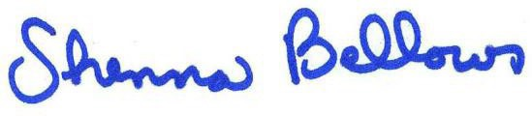
Shenna Bellows Secretary of State

